Section one: PES PMO Review
 | Function: | Project Execution Processes
* | Global Excellence Leader: | Mike Pye
* | PES PMO sponsor: | Peter Moore
* | Document prepared by: | Ray Spencer
 | Name of Initiative / Project: | Project Execution Reference Architecture

Brief description:

The PE Reference Architecture Initiative seeks to improve and rationalize Project Execution work processes, systems and information by developing a rational framework (a reference architecture) and a governance process to facilitate commonality and efficiencies. Initiative goals include:

1) Improve data availability and sharing
2) Improve information re-use
3) Improve data quality - creating a single “version of the truth”
4) Improving historical data retention
5) Establishing governance processes for a sustainable and scalable information infrastructure
6) Defining solution and process standards

Currently there is an assessment effort underway (in week 2 of 8) which will result in better definition of the scope and plans for the initiative. Below are the activities to be performed during the assessment and in more detail during the initiative:

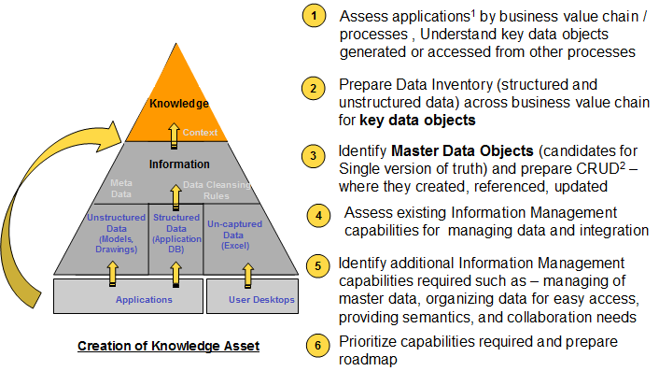

This initiative is directly aligned with the “Knowledge as a strategic asset” BTI theme and is a key enabler in supporting the BTI 2x2 concept (cost reduction and schedule improvement). Efficiencies required to execute in a lump sum business climate are directly supported by this initiative.

A number of groups are currently defining or are about to define the master data required at the start of the material life cycle for their respective disciplines. These groups include:
- Estimating – several groups
- Sourcing – several groups
- AcQyre
- Engineering
- Project Controls

Note: The Reference Architecture will be an on-going program which will require perpetual funding in order to maintain and sustain the objectives. This proposal is a four year view of the initiative, of which the prioritization of the Project Execution functions/processes will be defined.

Business value and key measures of success:
- Reduce time and effort required to gather data (a number of groups are spending significant hours in gathering data with little time left to fully consume and utilize data)
- Engineering design, schedule and estimating re-use and faster project startup
- Reduce costly data redundancy and instill confidence in data usage
- Improve project forecasting and estimating capabilities
- Improved client satisfaction in meeting their data needs (project turnover, timely project status, etc.)
- This initiative is a key enabler to most 2014 PES initiative proposals, including:
  - Project Controls
  - Estimating
  - Mechanical Data Manager
  - Optioneering
  - Supply Chain Initiatives (supplier information and spend analytics)

See the budget sheet and the attachments below for more benefits descriptions:


Start date: | 01/01/2014 | Expected completion date: | 12/31/2017

Full Cost of Initiative: : $12,931,000 over 4 years
Full Benefits of Initiative: This initiative is foundational to BTI initiatives, which have their respective ROI’s and benefit. See the benefits section of the cost sheet for more details on benefits.

Organizations Impacted | * |  | Organizations Impacted | *
Industry Groups |  |  | Functions
# Energy & Chemicals |  |  | Construction
# Government |  |  | Contract Management
# Global Services (O&M) |  |  | Data & Document Management
# Industrial & Infrastructure |  |  | Engineering
# Power |  |  | Estimating
 |  |  | Health, Safety, Environmental
Other organizations |  |  | Material Management
* Information Technology |  |  | Process Technology
* Automation |  |  | Project Automation
# Knowledge Enablement |  |  | Project Business Services
 |  |  | Project Controls
 |  |  | Project Management
 |  |  | Quality Assurance
 |  |  | Sales

Which Business Driver Components does this initiative address:
Fluor Strategic Plan |  | BTI Vision – Knowledge as a Strategic Asset, Self Perform Construction and Fabrication, and Lump Sum EPC
Business Line Strategic Plan
None

IT Governance Review Requirements |  |  | Data Classification
Required
# Commercial Tool Evaluation |  |  | Refer to Data Classification Chart  http://www.fdnet.com/security/Policies/000.671.0225a01_FluorDataClassificationChart.pdf
 |  |  | Note: Several tools required for the reference architecture platform will need to go through IT governance

1. Summary
The reference architecture solution will be comprised of a number of new tools and processes including:
- Data integration and BPM tools to manage data integration between processes
- Master Data Management tools and repositories to enforce data rules, system of record and data stewardship
- Enterprise Data Warehouse repositories for data sharing and analytics
- Data quality and governance tools and processes
- Enterprise Content Management (ECM) tools and repositories

Note: Specific tools/vendors have not yet been defined

2. Scope of Work

Overview
Detailed data, work process and application decomposition (analysis and requirements) and documentation will be the foundational activities required to develop and solution the reference architecture. Domains and business functions will be defined and prioritized for implementation over a four year duration. Implementations will be strategic and incremental. The solutions (outlined in section 1) will all be implemented to build the reference architecture framework within the first two years.

Major Activities
- Project execution work process, application and data decomposition.
- Detail requirements (iterations for each logical business function / data domain)
- Data Integration Implementations
- Master Data Management Implementations
- Data Warehouse implementations
- Data quality and governance process implementations
- Content Management (ECM) implementations
- On-going governance to maintain and sustain

Geographic Location
This is a global initiative impacting all geographies

Out of Scope
Corporate functions (e.g. HR, Finance and non project execution related processes)

Assumptions
Business line subject matter experts must be available to participate in detailed analysis and requirements activities.

3. Execution Plan

Overview
As a first step, an 8 week assessment was launched and is underway (started July 15, 2013). Completion of this step will result in high level plans and recommendations going forward. Detailed data process and solution analysis will be required, for each functional area which is addressed. These functional areas will be prioritized based on the impact and opportunity and in supporting strategic initiatives which are dependent on this initiative. The necessary components (as listed in section 2) will be designed, developed and implemented to meet the requirements within each of the data domains / business functions. The first implementation will involve deploying most of the tools sets, and thus will be more costly and time consuming compared to subsequent implementations.

Key Team Members
Core Team: PES GEL (Mike Pye, Mark Frisky), Materials Management (Brad Duke, Dale Carter) Material Management, IT Architecture, External Consultants (Currently Tata Consulting), PM (Ray Spencer)

Outside Services
Currently Tata Consulting Services is engaged in the assessment phase and may be engaged in subsequent phases.

Training
Three permanent Fluor roles are being proposed and may require training on new tools:
- Information Architect
- Solution Architect
- Work Process Architect

As tools are identified, training will likely be significant and widespread for business users.

Implementation Approach
The assessment phase, to be completed in September, 2013, includes deliverables that will describe a high level recommended approach.

4. Estimate / Budget / ROI
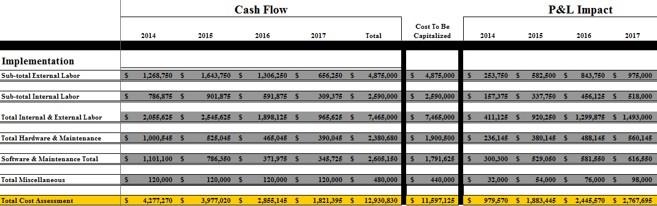

See attached cost model.

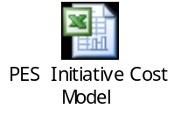

5. Schedule

Key Milestones
Specific milestones are to be determined following the assessment phase completion. Subject area / data domain priorities will need to be determined and will drive the milestones. The framework will likely be in place upon the completion of the second year.

6. Risk Assessment
This will need to be reviewed upon completion of the assessment phase.

Commercial Tool Purchase

Tools will be required and will be defined in subsequent detailed analysis phases. These will be put through all applicable PES and IT governance processes.

Governance Board Approved Not Approved
Participants / Function
Date / Comments

Revision | Date | Modification
0 | 00/00/200X | Original issue
1
2

Section Two: IT Governance Review

Tools will be identified after the assessment phase and subsequent tool selection analysis activities.

Type:
Application Service (xAAS/Cloud/Externally Hosted) Technology Other:

Is this a client driven requirement? Yes No

Is this an upgrade to an existing system? Yes No

Was the vendor/tool selected using the Corporate Procurement SmartSource Tool Assessment Process? Yes No

If No, how was this vendor selected ? Were other options considered? Please explain in detail the selection process.
Add text here

Approximately how many users require this solution? Are there plans to expand?
Add text here

Are interfaces required with other Fluor or non-Fluor systems? Yes No

TBD – there will likely be a combination of manual and automated interfaces. The goal is to automate as many as possible.

Will this application require IT support to install and/or maintain? Yes No
If yes, please explain in detail:
Tools are TBD.

